**CO 417 - Advanced Computer Graphics**

Coursework 1

Report

Part 1



Simple Tone Mapped

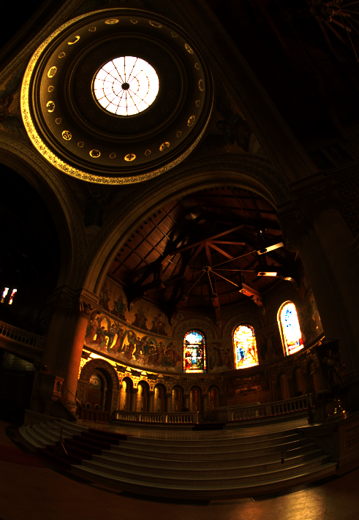

Exposed (8.8 Stops)

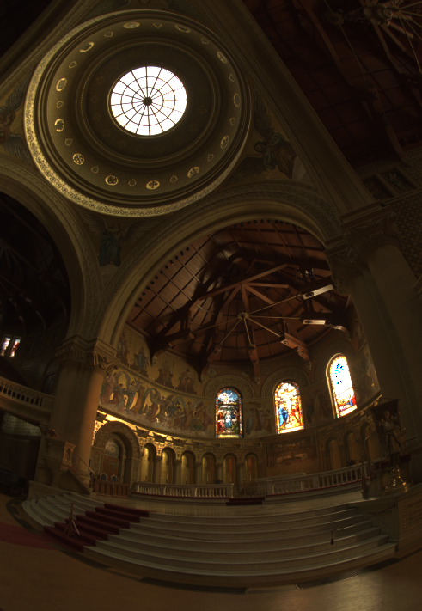

Gamma

Gamma Value **2.2** - Exposure **6** stops

Dynamic Range in PFM 1:39755.2

Part 2



Reflection Vectors

XYZ -> RGB

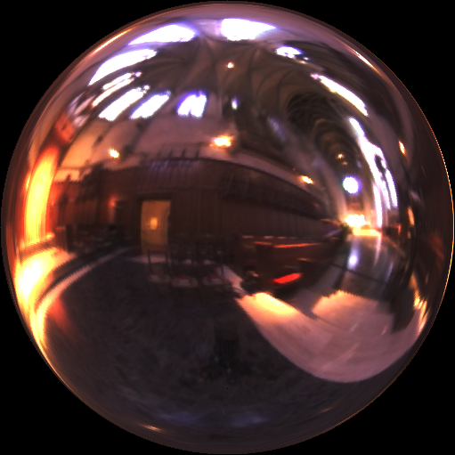

PPM Rendering

Gamma Value = 2.2

No alteration to Exposure